INOCA INTERNATIONAL – DAILY ANGINA/SYMPTOMS TRACKER - ABC FORM
(With thanks to Lisa Owens for designing this tracker – please feel free to customise this tracker to be specific to your own symptoms etc)

Date /Time Location | What happened right before the angina episode (Antecedent)  A = at rest  1 during the day,  2 woken from sleep  B = post exertion  1 walking, 2 showering,  3 drying hair, 4 housework,  5 other – please specify)  C = Environmental pollutants  1 noise, 2 lighting, 3 crowded  environment, 4 other – please  specify)  D = emotional stressor/situation  E = change in weather conditions  1 hot to cold, 2 cold to hot,  3 stormy, 4 other -please specify  F = other  G = unknown | Description of symptoms (Behaviour)  A = chest pain, central unless stated  1 sharp stabbing pain, 2 pressure,  3 ache/cramping, 4 burning,  5 other – please specify  B = across shoulder blades back pain  1 cramping, 2 sharp stabbing  pain, 3 other - please specify  C = jaw pain, left side unless stated  1 ache, 2 pins and needles,  3 sharp stabbing pain, 4 other -  please specify  D = arm pain, left side unless stated  1 deep ache top of arm,  2 deep ache elbow, 3 other –  please specify  E = exhaustion  (1 cannot keep eyes open – have  to sleep, 2 cannot perform usual  functions, 3 other -please  specify)  F = shortness of breath  G = ‘fizziness’ under skin  H = other – please specify | Duration Symptoms Lasting  A = less than 1 minute  B = lasting 1-10 minutes  C = 10-30 minutes  D = 30+ minutes  E = unknown | What helped calm the symptoms (Consequence)  A = deep breaths  B = rest  C = taking GTN spray/tablet  1 one dose = 2 sprays,  2 two doses, 3 three doses,  4 other- please specify  D = meditation  E = other rescue medication – please specify  F = 111 rung  G = GP contacted  H = A&E visit  I = ambulance called  J = other – please specify | Observations  BP/O2 etc
29.06.20  12.35  Front room | F – zoom meeting at work | C1, A1 | B | A, C1, | SO2 92%  BP 138/87

Tips on Filling in The INOCA International Daily Angina/ Symptom Tracker – ABC Form
(With thanks to Lisa Owens for designing this tracker – please feel free to customise the tracker to be specific to your own symptoms etc)

In our example we have colour coded each section to show which section relates to which part in the below statement –
On 29th June at 12.35 I was in a video meeting (F1) in the lounge when I got jaw pain that was an ache (C1), along with a stabbing chest pain (A1). The pains lasted approximately 6 minutes (B). I took a spray of GTN and did some deep breathing which eased the pain (A, C1). My oxygen levels and BP were SO2 92% BP 138/87

First add the date and time in the bottom left hand white box.

Then move to the next white box to the right (under 'what happened right before the angina episode’).

Look in the yellow boxes above to see which descriptions best fit your symptoms, for example, - if your symptoms came on at rest, during the day you would write 'A1' in the white box at the bottom of that column - with a description if you wish.

Work across the columns in the same way, matching your symptoms as you go.

Once you have completed the 4 columns you will then have a row of information at the bottom, from left to right, that details your symptoms that day.

Completing the tracker each day may help you to identify a pattern or triggers that are personal to you.

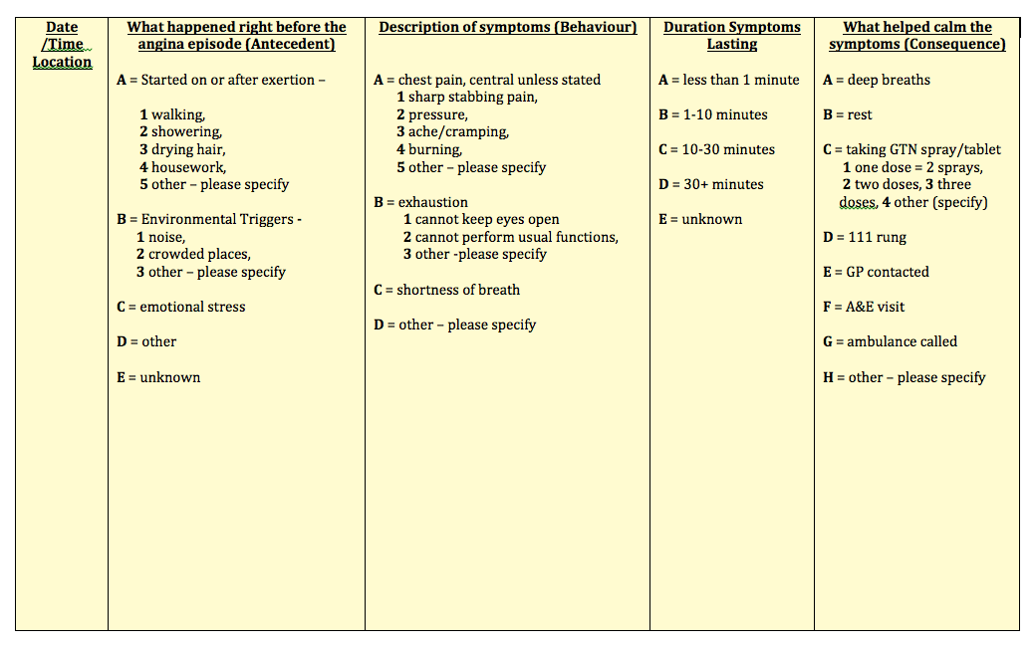
Customised 1 – a member with angina on exertion and/or due to environmental triggers and with chest pain/exhaustion symptoms
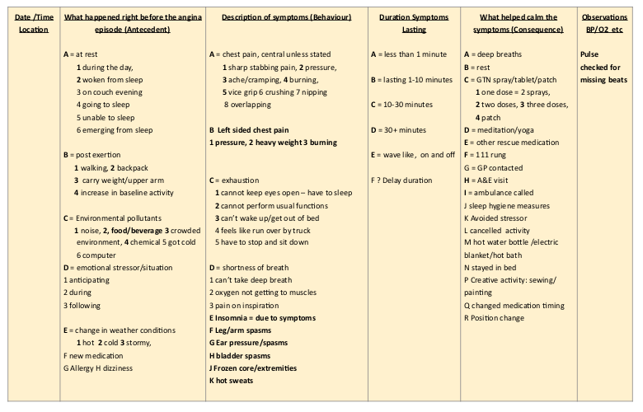
Customised 2 – a member experiencing angina at various times and in various circumstances with more diverse symptoms .

